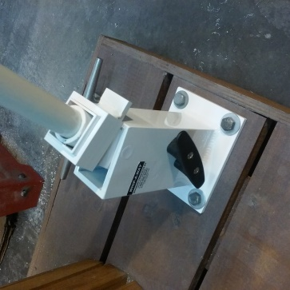
INSTALLATION INSTRUCTIONS SWIVEL

DECK MOUNTED MOORING WHIPS

The bases and fiberglass poles should be angled towards your boat when the bases are in the down position. Each support should be as close as possible in line with the bow and stern boat cleats they will bend from side to side like a fishing rod.

Mount supports approx. 1-2” from the edge of your dock try to have at least two of the four 3/8” bolts enter the dock beam support if it is a wooden dock. Mount with 3/8” ss or galvanized lag bolts and washers.

Assemble the two pole sections by placing the 1” pole into the aluminum coupling and tighten the set screw. Thread one line through the pulley so the line ends are equal (looped and cutoff end) hold lines together make sure pole support is vertical and locked in place. Slide 1” pole into base support. Be sure pulley is hanging down and free. Insert the cut off end of the line through the middle of the cleat then tie a knot so the line stays attached to the cleat. Always attach the looped line ends to the dockside of your boat cleats as soon in sketch.

Attach separate dock lines both for the bow and the stern adjust for desired distance away from your dock, tighten whip lines enough to keep your boat away from the dock approx. 3’-4’ secure line on pole cleat. The sketch below is a suggestion other mounting arrangements may be used depending on the position of your boat including spring lines to prevent your boat from moving forward or back parallel to your dock.

OPERATION: When leaving the dock release the line from the whip pole cleat, release the line from your boat cleat. Swivel the pole vertically they will lock in place. When returning, release the lock by sliding the drop lock square up and gently lowering the poles towards your boat attach the line to your boat cleat adjust the line until the poles flex and your boat is at a distance desired from the dock and secure the line to the support cleat: Note it is better to adjust your boat at low tide. When at high tide additional adjusting may be necessary. If you have any questions please call customer service at 954-298-4890

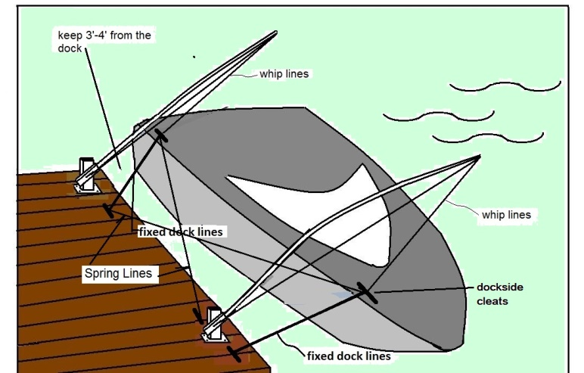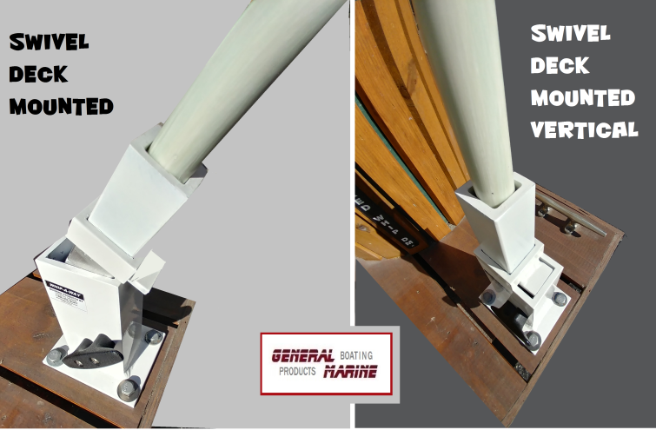

Thank you for purchasing our products. After using our product and you are completely satisfied, we would like other potential customers to know about your wise choice. So, we would appreciate it if you go back to where you purchased your whips and leave a (hopefully favorable) review. We know your time is valuable so as an incentive we will provide to you our extended 2 yr. warrantee a value of $50.00 at no charge.

