INSTALLATION INSTRUCTIONS SWIVEL

PILING MOUNTED MOORING WHIPS

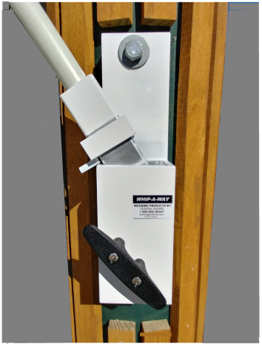
For piling mounted whips select a left and right support, the fiberglass poles should be angled towards your boat when the poles are in the down or working position. Each support should be as close as possible in line with the bow and stern boat cleats, act like fishing poles the alignment does not have to be exact. Supports may be mounted on either left or right side of the piling. The supports may also be rotated around the piling angling the whip lines closer to your dock side boat cleats.

Mount supports approx. 3-4 feet above the deck on the piling or a little below shoulder height. Mount with ½” ss or galvanized lag bolts 4-5” long with flat washers. Mount directly to the piling face remove any decorative material or obstructions. Mount the channel to the piling with the two holes provided. Mark top hole, then drill under sized pilot hole (suggested 3/8 to7/16”) then snug top mounting bolt. When the base is vertical mark the bottom hole then drill. Then tighten both mounting bolts.

Assemble the two pole sections by placing the 1” pole into the aluminum coupling and tighten the set screw. Thread one line through the pulley so the line ends are equal (looped and cutoff end) hold lines together with pole make sure pole support is vertical and locked in place. Slide pole into pole support. Insert the cut off end of the line through the middle of the cleat then tie a knot so the line stays attached to the cleat. Always attach the looped line ends to the dockside of your boat cleats as soon in sketch.

Attach separate dock lines both for the bow and the stern adjust for desired distance away from your dock, tighten whip lines enough to keep your boat away from the dock approx. 3’-4’ secure line on pole cleat. The sketch below is a suggestion other mounting arrangements may be used depending on the position of your boat including spring lines to prevent your boat from moving forward or back parallel to your dock.

OPERATION: When leaving the dock release the line from the whip pole cleat; release the line from your boat cleat. Swivel the pole vertically they will lock in place automatically. When returning, release the lock by sliding the drop lock square up and gently lowering the poles towards your boat attach the line to your boat cleat adjust the line until the poles flex and your boat is at a distance desired from the dock and secure the line to the support cleat: Note it is better to adjust tension when your boat is at low tide. When at high tide additional adjusting may be necessary. If you have any questions please call customer service at 954-298-4890

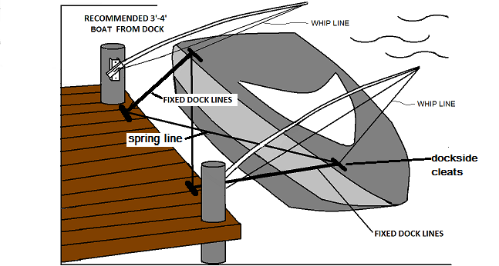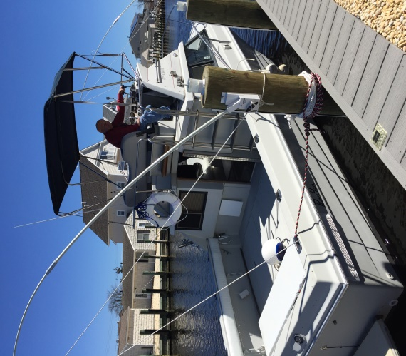

Thank you for purchasing our products. After using our product and you are completely satisfied, we would like other potential customers to know about your wise choice. So, we would appreciate it if you go back to where you purchased your whips and leave a (hopefully favorable) review. We know your time is valuable so as an incentive we will provide to you our extended 2 yr. warrantee a value of $50.00 at no charge.

